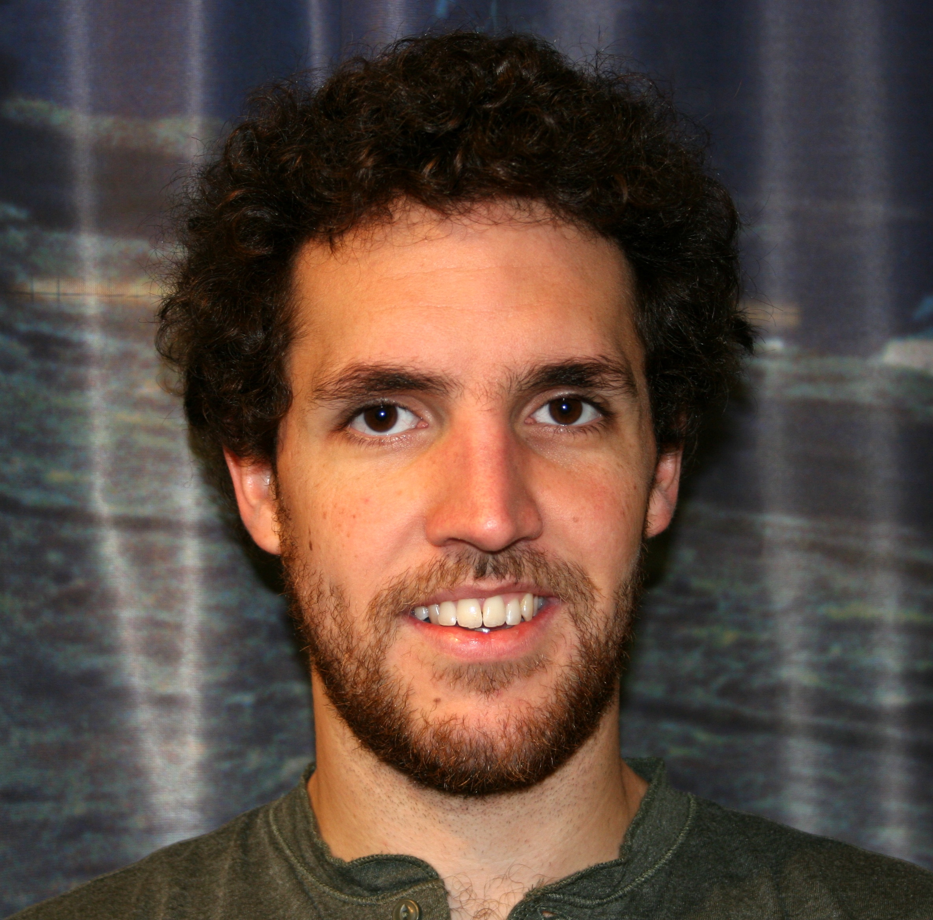
Curriculum Vitae
PERSONAL INFORMATION
Family name, First name: Nixon, Casey William
Date of birth: 25.04.1988
Sex: Male
Nationality: United Kingdom
URL for personal web site: http://www.uib.no/en/persons/Casey.Nixon
CURRENT AND PREVIOUS POSITIONS
2015-Present Vista Scholar – Norwegian Academy of Science and Letters
Department of Earth Science, University of Bergen, Norway
2015-Present Visiting Fellow
Ocean and Earth Sciences, University of Southampton, UK
2014-2015 Teaching and Research Fellow
Ocean and Earth Sciences, University of Southampton, UK
2013-2014 Postdoctoral Research Fellow
Ocean and Earth Sciences, University of Southampton, UK
EDUCATION
2013 PhD: Analysis of fault networks and conjugate systems Disputation date: 05.03.2013.
Ocean and Earth Sciences, University of Southampton, UK
Supervisors: Prof David Sanderson & Prof Jonathan Bull
2009 BSc Hons Degree in Geology 1st
School of Geosciences, University of Edinburgh, UK
AWARDS, ACHEIVEMENTS AND PRIZES
2017-2019 Invited Member of the Science Party for IODP Expedition 381: Corinth Active Rift Development, managed by ECORD Science Operator
2015-2018 Awarded VISTA Scholarship and associated research funding (2,812,000 NOK)
2014-2018 Successful IODP Full Proposal for drilling offshore Corinth Rift – Scheduled for Oct 2017
2015 Awarded mobility funds from the Akademia Agreement between Statoil and University of Bergen (50,000 NOK)
2009-2013 NERC Case Studentship (PhD): University of Southampton, UK
2011 Outstanding Student Paper Award, Hydrology Section, American Geophysical Union Fall Meeting
2011 Winner of the Shell Award, Tectonic Studies Group, Geological Society of London
2011 Winner of the Mike Coward Prize, Tectonic Studies Group, Geological Society of London
2009 Awarded a NERC funded PhD with a CASE Studentship, University of Southampton
2009 Awarded University of Edinburgh Laidlaw-Hall Trust funding, University of Edinburgh
2008 Total Oil Marine Prize, University of Edinburgh
2007 Class Medal Award for Mineralogy and Petrology, University of Edinburgh
CURRENT RESEARCH PROJECTS
‘Topology of Normal Fault Networks in Rift Basins’ funding: VISTA, Norwegian Academy of Science and Letters (2015-2018); Main Institutes: University of Bergen, University of Southampton, Manchester University, Imperial College London; 7 Participants
‘An Integrated Geological and Mathematical Framework for the Characterization, Modelling and Simulation of Fractured Geothermal Reservoirs (ANIGMA)’ funding: ENERGIX Program, Research Council of Norway (2015-2019); Main Institutes: University of Bergen, UniResearch CIPR, University of Southampton; 11 Participants.
‘Drilling the Corinth Rift: Resolving the detail of active rift development’ IODP Full Proposal (2014-2018); Main Institutes: University of Southampton, University of Exeter, Imperial College London, University of Leeds, University of Bergen, University of Patras, Universite de Lorraine, Hellenic Centre for Marine Research (HCMR), plus 10 others; 27 Participants.
TEACHING ACTIVITIES
2016 Temporary Associate Professor – University of Bergen, Norway
Courses: GEOV105: Introduction to historical geology and palaeontology

2014-2015 Teaching and Research Fellow – University of Southampton, UK

Courses: SOES2033: Structural geology, SOES2033: GIS and remote sensing, SOES2034: Key skills and fieldwork for geologists, SOES1003 IT communication, field & laboratory skills
PhD Supervision
2015-Present Melanie Siegburg, PhD candidate, University of Southampton, UK: “Tectono-magmatic activity at the Boset-Bericha Volcanic Complex in the Main Ethiopian Rift”
Supervisors: T.M. Gernon, J.M. Bull, D. Keir, C.W. Nixon, R.N. Taylor
Masters Supervision
2017-Present F. Wyller, “Spatial and temporal development of joint networks and associated network properties” Master of Geology, University of Bergen, Norway
2017-Present M. Krabbendam, “Integrated 4D tectono-stratigraphic evolution of the northern Peloponnese margin and the Gulf of Corinth, Greece” Master of Geology, University of Bergen, Norway
2015-2017 S. Vaagan, “Distribution of deformation associated with relay and tip damage zones of normal faults – a case study from Kilve, UK” Master of Basin and Reservoir Studies, University of Bergen, Norway
2015-2017 E. Wiese, “Influence of pre-existing structures on the development of normal fault networks in the Browse Basin, NW Australia” Master of Basin and Reservoir Studies, University of Bergen, Norway
2014-2016 K. Nærland, “Topology of normal fault damage zones in carbonate rocks, Malta – implications for the development of connectivity in evolving fault networks” Master of Petroleum Geoscience, University of Bergen, Norway

2014-2016 S. Sletten, “Normal fault growth and fault zone architecture of normal faults exposed in the Corinth Canal, central Greece” Master of Petroleum Geoscience, University of Bergen, Norway
2014-2015 L. Collins, “Investigating the distribution of faulting and extension in the Corinth Canal, Greece” Msci Geophysics research project, University of Southampton, UK
2013-2014 A. Moyle, “A comprehensive analysis of the distribution of displacement across the Corinth rift, Greece” Msci Geology research project, University of Southampton, UK
2013-2014 L. Turner, “Mapping of the Dabbahu Rift and theories on fault structure and growth” Msci Geophysics research project, University of Southampton, UK
ORGANISATION OF SCIENTIFIC MEETINGS
2015 Lead Convener - Topology and Fluid Flow: Workshop, 22 participants, University of Bergen, Norway
2014 Co-Convener - IODP Ocean Drilling Within the Corinth Rift, Greece: Megellan Meeting, 36 participants, Hellenic Centre for Marine Research, Greece
POSITIONS OF RESPONSIBILITY
2017-2019 Member of Science Party on IODP Expedition 381 managed by ECORD Science Operators
2011-2013 Post Graduate Representative of Tectonic Studies Group, Geological Society of London
2010-2012 President of University of Southampton AAPG Student Chapter, American Association of Petroleum Geologists
PUBLICATION TRACK RECORD
Citations per year since 2014 (Google Scholar)
Statistics
- 13 published journal articles
- 8 submitted journal manuscripts
- 1 scientific report
- 1 PhD Thesis
- 12 online conference abstracts (AAPG, AGU, EGU)
- 128 citations (>125 since 2014)
- H-index: 8 (Google Scholar)
- i10-index: 5 (Google Scholar)

Peer Reviewed Publications
Published:
# citations
¹Dimmen, V., Rotevatn, R., Peacock, D.C.P., Nixon, C.W., Nærland, K., 2017. Quantifying structural controls on fluid flow: insights from carbonate-hosted fault damage zones on the Maltese Islands. Journal of Structural Geology 101, 43-57.
⁴Peacock, D.C.P., Nixon, C. W., Rotevatn, A., Sanderson, D.J., 2017. Interacting faults. Journal of Structural Geology 97, 1-22.
¹Duffy, O.B., Nixon, C. W., Bell, R.E., Jackson, C.A-L., Gawthorpe, R.L., Sanderson, D.J., Whipp, P.S., 2017. Topology of evolving rift fault networks: Single-phase vs multi-phase rifts. Journal of Structural Geology 96, 192-202.
Peacock, D.C.P., Korneva, I., Nixon, C.W., Rotevatn, A. 2017. Changes of scaling relationships in an evolving population: The example of “sedimentary” stylolites. Journal of Structural Geology 96, 118-133.
¹³Peacock, D.C.P., Nixon, C. W., Rotevatn, A., Sanderson, D.J., Zuluaga, L.F., 2016. Glossary of fault and fracture networks. Journal of Structural Geology, 92, 12-29.
⁸Nixon, C.W., McNeill, L.C., Bull, J.M., Bell, R., Gawthorpe, R., Henstock, T., Christodoulou, D., Ford, M., Taylor, B.,Sakellariou, D., Ferentinos, G., Papatheodorou, G., Leeder, M., Collier, R., Goodliffe, A., Sachpazi, M., Kranis, H., 2016. Rapid spatiotemporal variations in rift structure during development of the Corinth Rift, central Greece. Tectonics, 35, 1225-1248.
¹⁰Morley, C.K. & Nixon, C.W., 2016.Topological characteristics of simple and complex normal fault networks. Journal of Structural Geology, 84, 68-84.
⁵Ayele, A., Ebinger, C.J., van Alstyne, C., Keir, D., Nixon, C.W., Belachew, M., Hammond, J.O.S, 2015. Seismicity and the Tendaho Dam safety, Afar (Ethiopia): risk implications for downstream population. Geol. Soc. London. Spec. Publ., 420.
²⁸Sanderson, D.J. & Nixon, C.W., 2015. The use of topology in fracture network characterization. Journal of Structural Geology, 72, 55-66.
²McNeill, L.C., Sakellariou, D., Nixon, C.W., 2014. Drilling to resolve the evolution of the Corinth Rift. Eos Transactions. 29, 170.
⁸Nixon, C.W., Sanderson, D.J., Bull, J.M., 2014. Localized vs distributed deformation associated with an active normal fault, Whakatane, New Zealand. Journal of Structural Geology 69, 266-280.
¹⁸Nixon, C.W., Sanderson, D.J., Dee, S., Bull, J.M., Humphreys, R., Swanson, M., 2014. Fault interactions and reactivation within a normal fault network at Milne Point, Alaska. AAPG Bulletin. 98(10), 2081-2107.
⁹Nixon, C.W., Sanderson, D.J., Bull, J.M. 2012. Analysis of a strike-slip fault network using high resolution multibeam bathymetry, offshore NW Devon U.K.. Tectonophysics, 541-543, 69-80.
¹⁹Nixon, C.W., Sanderson, D.J., Bull, J.M. 2011. Deformation within a strike-slip fault network at Westward Ho!,Devon U.K.: Domino vs conjugate faulting. Journal of Structural Geology, 33, 833-843.

Submitted:
Nixon, C.W., Vaagan, S., Sanderson, D.J., Gawthorpe, R.L., In Review. Spatial distribution of damage and strain within a relay, Kilve U.K.. Journal of Structural Geology.
Sanderson, D.J., Peacock, D.C.P., Rotevatn, R., Nixon, C.W., In Review. Fracture Networks: Back to the Future. Journal of Structural Geology.
Bell, R.E., Duclaux, G., Nixon, C.W., Gawthorpe, R.L., McNeill, L.C., In Revison. High-angle faults control the
geometry and morphology of the Corinth Rift. Geology.
Nyberg, B., Nixon, C.W., Sanderson, D.J., In Review. NetworkGT: A GIS tool for the geometric and topological analysis of fracture networks. Geosphere.
Sævik, P. & Nixon, C.W., In Revision. Effective permeability of fractured rock from topological measurements. Water Resources Research.
Nixon, C.W., Sanderson, D.J., Putz-Perrier, M.W., Bull, J.M., In Revision. Variations in the contribution of seismically unresolvable faults to extension in the Earth’s upper crust. Geology.
Sanderson, D.J. & Nixon, C.W., In Revision. Topology, connectivity and percolation in fracture networks, Journal of Structural Geology.
Hall, T., Nixon, C.W., Keir, D., Ayele, A., Burton, P., In Revision. Earthquake clustering and seismic hazard of the African-Arabian rift system. Bulletin of Seismological Society of America.
CONFERENCES AND INVITED TALKS
Record of Presenting at International Conferences:
American Geophysical Union General Assembly: 2011, 2012, 2013, 2014, 2017
Tectonic Studies Group Annual Meeting: 2010, 2011, 2012, 2014, 2016
European Geophysical Union General Assembly: 2013, 2015
AAPG Convention Exhibition: 2016
European Geothermal Congress: 2016
Geometry and Growth of Normal Faults, Geological Society, London: 2014

Invited Talks
2016 Invited lecture on an international short course on development of deep geothermal resources at the European Geothermal Congress
‘Characterization, modelling and simulation of fractured reservoirs’
2014 Invited talk for the Basin Research Group seminar series at Imperial College London
‘Localization of deformation within rifts – from rift architecture to fault networks’
2013 Invited talk for the Structural Geology COP talk series at BP Exploration, Sunbury.
‘Characterising the deformation within fault networks’
MEMBERSHIPS AND OTHER QUALIFICATIONS
American Association of Petroleum Geologists, American Geophysical Union, European Geophysical Union,
Sea Survival Certificate, Full Driver’s License

